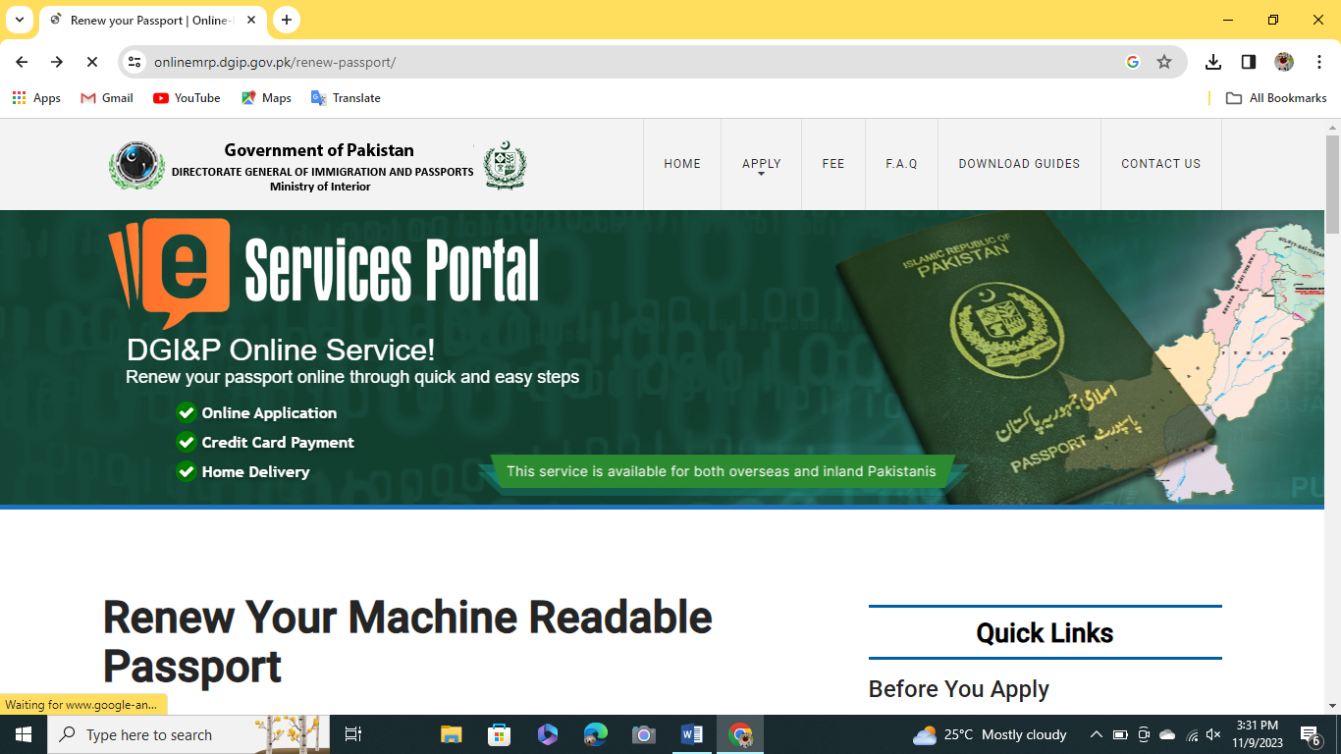
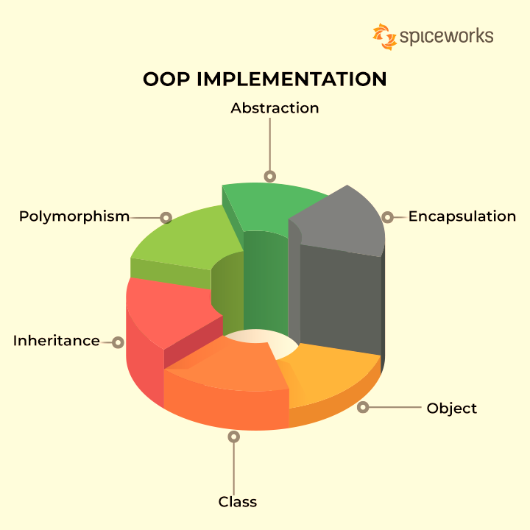

Passport Registration System

Group Members

ISHA BATOOL 4735-FOC/BSCS/F22A

MINHAIL JAVED 4722-FOC/BSCS/F22A

SHAIRBANO 4727-FOC/BSCS/F22A

PROJECT: PASSPORT REGISTRATION SYSTEM
Introduction:
Passport registration is the official process through which an individual applies for and obtains a government-issued document that grants them permission to travel internationally, serving as proof of their citizenship and identity.
The "Pakistan Passport Registration" typically refers to the process of applying for a passport in Pakistan. Pakistan issues different types of passports, including regular, official, and diplomatic passports, to its citizens for various purposes.
In our semester project we will implement some features of passport registration using concept of object-oriented programming (OOP) to achieve data hiding, encapsulation, abstraction etc.
Programming Techniques Implement in Our Project:
We were implementing the following important techniques or features in our project:
- Register Account:
It allows to register account by entering the I’d, first or last name, CNIC, phone no, nationality, age, gender, email, password and then your registration will be successful.
- Login details:
It allows user to login their account by entering password /email / phone no.
- Change Password:
This feature allow user to change password by entering his/her old password. In that case if user think his/her old password is not secure.
- Forger Password:
If user not remember their old password this feature allow user to forget their old password and re-enter new password but make sure user remember their e-mail id.
- Account Expiry:
This feature allow user to check expiry date of their account. when user register account, passport id is generated and display on screen. User enter this id to find out expiry date. Remember that passport id is different for each member.
- View Details:
This feature allows to view all accounts but only passport manager or administrator can see all accounts detail. So, by enter administrator id or password user can view all accounts detail.

Programming language: C++
PROGRAM:
Program can write in three different files
- Main.cpp file (source file)
- Classname.h file (header file)
- Classname.cpp file (source file)
Class name.h file:
#pragma once
#include<iostream>// basic input output library
#include<iomanip>// input output manipulations
#include<cstdlib>// for Srand or Rand
#include<string>// for string
#include<ctime>// for time(NULL)
#include<cctype>// for isalpha ans isspace
#include<fstream>//for file handling
using namespace std;
const int max_count = 100;// const variable initiallize
class passport
{
protected:
// data members
int count = 0;
string first_name[max_count];// array to store records
string last_name[max_count];
string email[max_count];
string CNIC[max_count];
long int ph_no[max_count];
string pasword[max_count];
int age[max_count];
char gender[max_count];
int id[max_count];
double fee;
string nationality[max_count];
public:
// member functions
void passport_registation(fstream& outputfile);// function to register account
void userfee_details();
void view_details();// display list

};
class login_details :protected passport
{
public:
// Member Functions
void login();
void change_pasword();
void forget_pasword();
};
void display();
class sideinfo :protected login_details
{

public:
void expiry();
friend void display();// declare as a friend function
};

Class name.cpp file:
#include "passport.h"
#include<iostream>// basic input output library
#include<iomanip>// input output manipulations
#include<cstdlib>// for Srand or Rand
#include<string>// for string
#include<ctime>// for time(NULL)
#include<cctype>// for isalpha ans isspace
#include<fstream>//for file handling
using namespace std;
void passport::passport_registation(fstream& outputfile)
{
int ID;
if (count == max_count)// If size reach to maximum size
{
cout << "SORRY LIST FULL\n";
}
else
{
cout << "--------------------------------------------------------------------------------------------------------\n";
cout << "\n PASSPORT REGISTATION\n";
//srand(time(NULL));
ID = rand() % 10000000000;// To assign random id to each member
cout << "PLEASE ENTER FIRST NAME: ";
cin >> this->first_name[count];
for (char c : first_name[count])
/*For each character c in the string,
it checks if c is not alphabetic and
not a space using !isalpha(c) && !isspace(c).*/
{
if (!isalpha(c) && !isspace(c))
{
cout << " INALID NAME\n";
do
{
cout << "Please Re_Enter First name:\n";
cin >> first_name[count]; // Name should consist of alphabetic characters
} while (isalpha(c));

}
}
outputfile << "\nFIRST NAME:" << first_name[count] << "\n"; // write data into file
cout << "PLEASE ENTER LAST NAME: ";
cin >> this->last_name[count];
for (char c : last_name[count])
{
if (!isalpha(c) && !isspace(c))
{
cout << " INALID NAME\n";
do
{
cout << "Please Re_Enter Last name:\n";
cin >> last_name[count]; // Name should consist of alphabetic characters
} while (isalpha(c));
}
}
outputfile << "LAST NAMEE:" << last_name[count] << "\n";
cout << "PLEASE ENTER YOUR CNIC: ";
cin >> CNIC[count];
for (char c : CNIC[count])
{
if (isalpha(c))//Function to identify alphabets
{
cout << " INALID CNIC\n";
do
{
cout << "Please Re_Enter CNIC:\n";
cin >> CNIC[count];
} while (!isalpha(c) && isspace(c)); // CNIC should consist of number and spaces

}
}
outputfile << "CNIC:" << CNIC[count] << "\n";
cout << "PLEASE ENTER YOUR PH NO:+92";
cin >> this->ph_no[count];
outputfile << "PHONE NO:" << ph_no[count] << "\n";
cout << " ENTER NATIONALLITY:";
cin >> this->nationality[count];

for (char c : nationality[count]) {
if (!isalpha(c) && !isspace(c)) {
cout << " INALID NATIONALITY\n"; // Nationality should consist of alphabetic characters
do
{
cout << "Please Re_Enter Nationality:\n";
cin >> nationality[count];
} while (isalpha(c));
}
}
outputfile << "NATIONALITY:" << nationality[count] << "\n";
cout << "PLEASE ENTER YOUR AGE:";
cin >> this->age[count];
if (age[count] < 5 || age[count]>100)// checks Restriction on age
{
cout << "INVALID AGE\n";
do {
cout << "PLEASE RE ENTER YOUR AGE:";
cin >> this->age[count];
} while (!(age[count] > 5 || age[count] < 100));
}
outputfile << "AGE:" << age[count] << "\n";
do {
cout << " Please Enter Gender(F/M):";
cin >> this->gender[count];

} while (!(gender[count] == 'f' || gender[count] == 'F' || gender[count] == 'M' || gender[count] == 'm'));
// loop will execute till user inter correct gender (f/m)
cout << "PLEASE ENTER EMAIL: ";
cin.ignore();
cin >> this->email[count];
outputfile << "EMAIL:" << email[count] << "\n";
cout << "PLEASE ENTER PASWORD: ";
cin.ignore();
cin >> this->pasword[count];
outputfile << "PASWORD:" << pasword[count] << "\n";
id[count] = ID;
outputfile << "PASSPORT ID:" << id[count] << "\n";
outputfile.close();

}
}
void passport::userfee_details()
{
int option;
do {
cout << "\n_______________________________________________________________________________________________________\n";
cout << "\n FEE DETAILS\n";
cout << "\n_______________________________________________________________________________________________________\n";
cout << "|sno\t\tFee\t\t\tPeriod\t\tFee Details |\n";
cout << "|1.\t\tURGENT FEE\t\t5Years\t\t15,000 |\n";
cout << "|2.\t\tNORMAL FEE\t\t5Years\t\t10,000 |\n";
cout << "\n__________________________________________________________________________________________________\n";
cout << "Enter option:";
cin >> option;
switch (option)
{
case 1:
{
cout << "PLEASE ENTER FEE:\n";
cin >> fee;
if (fee >= 15000)
{
cout << "Your Return:" << fee - 15000 << "/Rs" << endl;
cout << "\nREGISTATION SUCCESSFULL------------------\n";
cout << "\nYOUR PASPORT ID:" << this->id[count] << endl;
count++;
}
else
{
cout << "INSUFFIENT AMOUNT\n";
cout << "Sorry registration failed.........\n";
}
break;
}
case 2:
{
cout << "PLEASE ENTER FEE:\n";
cin >> fee;
if (fee >= 10000)
{
cout << "Your Return:" << fee - 10000 << "/Rs" << endl;
cout << "\nREGISTATION SUCCESSFULL------------------\n";
cout << "\nYOUR PASPORT ID:" << this->id[count] << endl;
count++;
}
else
{
cout << "INSUFFIENT AMOUNT\n";
cout << "Sorry registration failed.........\n";
}
break;
}
default:
cout << "Invalid option\n";
break;
}
} while (!(option == 1 || option == 2));
}
void passport::view_details()
//this feature allow to fiew all accounts but only manager can view all account
{
string mail, pas;
if (count == 0)// check if list is empty
{
cout << "EMPTY LIST-------\n";
}
else
{
cout << "PLEASE ENTER (EMAIL) AND (PASWORD) TO LOGIN PAGE:\n";
cout << "MAKE SURE YOUR EMAIL /PASWORD WILL MATCH WITH ADMINISTRATOR EMAIL AND PASWORD.....\n";
cout << "E_mail:";
cin.ignore();
cin >> mail;
cout << "pasword:";
cin.ignore();
cin >> pas;
if (mail == "admin123@gmail.com" && pas == "admin123$")
{
// display all accounts
cout << "------------------------------------------------------------------------------------------------------\n";
cout << " VIEW ACCOUNTS\n";
for (int i = 0; i < count; i++)
{
cout << "\n\t\t\tACCOUNT " << i + 1 << ":" << endl;
cout << "FIRST NAME:" << this->first_name[i] << endl;
cout << "LAST NAME:" << this->last_name[i] << endl;
cout << "CNIC:" << this->CNIC[i] << endl;
cout << "AGE:" << this->age[i] << endl;
cout << "GENDER:";
if (gender[i] == 'f' || gender[i] == 'F')
{
cout << " Female " << endl;
}
else
{
cout << " Male" << endl;
}
cout << "NATIONALITY:" << this->nationality[i] << endl;
cout << "EMAIL:" << this->email[i] << endl;
cout << "PASSPORT ID:" << this->id[i] << endl;

}
}
else
{
cout << "SORRY! YOU ENTER INCORRECT EMAil AND PASWORD (NOT MATCH WITH ADMINISTRATOR EMAIL OR PASSWORD)\n";

}

}
}

void login_details::login()// To login account
{
bool F = false;
string pas;
cout << "------------------------------------------------------------------------------------------------------\n";
cout << " LOGIN\n";
cout << "\nPlease Enter Password To Login Your Account\n";
cin >> pas;
for (int i = 0; i < count; i++)
{
if (pas == pasword[i])// check pasword enter by user will match with register pasword
{
F = true;
cout << " LOGIN SUCCESSFULL\n";
cout << "FIRST NAME:" << this->first_name[i] << endl;
cout << "LAST NAME:" << this->last_name[i] << endl;
cout << "CNIC:" << this->CNIC[i] << endl;
cout << "AGE:" << this->age[i] << endl;
cout << "GENDER:";
if (gender[i] == 'f' || gender[i] == 'F')
{
cout << " Female " << endl;
}
else
{
cout << " Male" << endl;
}
cout << "NATIONALITY:" << this->nationality[i] << endl;
cout << "EMAIL:" << this->email[i] << endl;
cout << "PASSWORD:" << this->pasword[i] << endl;
cout << "PHONE NO:+92" << this->ph_no[i] << endl;
cout << "PASSPORT ID:" << this->id[i] << endl;

}
}
if (F == false)// if pasword not match display massage account not found
{
cout << " Account NOT Found\n";
}
}
void login_details::forget_pasword() // To forget pasword if user not remember his/her old pasword
{
bool F = false;
string e_id, pass;
cout << "_________________________________________________________________\n";
cout << " FORGET PASWORD\n";
cout << "\tENTER YOUR EMAIL ID:";
cin >> e_id;
for (int i = 0; i < count; i++)
{
if (e_id == email[i])// loop execute to check email that is enter by the user match with register email
{
F = true;
cout << "\t\tENTER NEW PASWORD:";
cin >> pass;
pasword[i] = pass;
cout << "FORGET PASSWORD SUCCEFULL\n";
cout << "New Pasword:" << pasword[i] << endl;
}
}
if (F == false)// if condition not true this loop will execute
{
cout << " EMAIL ID NOT Found\n";
}
}
void login_details::change_pasword()
{
bool F = false;
string pas, pass;
cout << "\t\tENTER OLD PASSWORD:";
cin >> pas;
for (int i = 0; i < count; i++)
{
if (pas == pasword[i])
{
F = true;
cout << "\t\tENTER NEW PASWORD:";
cin >> pass;
pasword[i] = pass;
cout << "PASSWORD CHANGE SUCCESSFULL-----\n";
cout << "___________________________________________YOUR ACCOUNT_________________________________\n";
cout << "FIRST NAME:" << first_name[i] << endl;
cout << "LAST NAME:" << last_name[i] << endl;
cout << "CNIC:" << CNIC[i] << endl;
cout << "AGE:" << age[i] << endl;
cout << "GENDER:";
if (gender[i] == 'f' || gender[i] == 'F')
{
cout << " Female " << endl;
}
else
{
cout << " Male" << endl;
}
cout << "NATIONALITY:" << nationality[i] << endl;
cout << "EMAIL:" << email[i] << endl;
cout << "PASSWORD:" << pasword[i] << endl;
cout << "PHONE NO:+92" << ph_no[i] << endl;
cout << "PASSPORT ID:" << id[i] << endl;
}
}
if (F == false)// if pasword not match with register pasword
{
cout << " INVALID PASSWORD\n";
}

}
void sideinfo::expiry()
{
int Pas_id;
bool F = true;
int day, month, year;
cout << "ENTER YOUR PASSPORT ID:\n";
cin >> Pas_id;// this is a random id assign to every member and every member have a different passport id
for (int i = 0; i < count; i++)
{
if (Pas_id == id[i])
{
F = true;
cout << "Enter Register Date:\n";

cout << "Enter Days:";
cin >> day;
cout << "Enter Month:";
cin >> month;
cout << "Enter Year:";
cin >> year;
do {
if (day <= 1 && day >= 31 && month <= 1 && month >= 12 && year > 2019 && year < 2024)// resitriction on invalid date
{
cout << "INVALID DATA\n";
cout << "Re_Enter Data\n";

cout << "Enter Days:";
cin >> day;
cout << "Enter Month:";
cin >> month;
cout << "Enter Year:";
cin >> year;
}
} while (!(day >= 1 && day <= 31 && month >= 1 && month <= 12 && year >= 2020 && year <= 2023));
cout << "\nREGISTER DATE:" << day << "-" << month << "-" << year << endl;
cout << "EXPIRY DATE:" << day << "-" << month << "-" << year + 5 << endl;
cout << "After Five Year Your Card Will Expire\n";
}
}
if (F == false)
{
cout << "Passport Not Found\n";
}

}
Main.cpp file:
#include<iostream>// basic input output library
#include"passport.h"
#include<iomanip>// input output manipulations
#include<cstdlib>// for Srand or Rand
#include<string>// for string
#include<ctime>// for time(NULL)
#include<cctype>// for isalpha ans isspace
#include<fstream>//for file handling
using namespace std;

void display()
{
fstream outputfile;//create object of fstream class
outputfile.open("passport_reg.txt", ios::out);
if (!outputfile)//if file not found
{
cout << "FILE NOT CREATED\n";
}
outputfile << "\t\t\tPASSPORT REGISTRATION\n\n";// write data into file

sideinfo* p;// object of sideinfo class
sideinfo p1;
p = &p1;
int opt;
do
{
// display menu
cout << "___________________________________________________________________________________________\n";
cout << "\n\n PASSPORT \n";
cout << "___________________________________________________________________________________________\n";
cout << " |1.To REGISTER ACCOUNT |\n";
cout << " |2.TO LOGIN ACCOUNT |\n";
cout << " |3.To CHANGE PASWORD |\n";
cout << " |4.TO FORGET PASWORD |\n";
cout << " |5.To CHECK ACCOUNT EXPIRY|\n";
cout << " |6.VIEW ALL ACCOUNTS |\n";
cout << " |7.TO EXIST...............|\n";
cout << "___________________________________________________________________________________________\n";
cout << "\t\tENTER OPTION TO SELECT:";
cin >> opt;
switch (opt)
{
case 1:
{
p->passport_registation(outputfile);//passing object of fstream class as a pointer
p->userfee_details();
break;
}
case 2:
{
p->login();

break;
}
case 3:
{
p->change_pasword();
break;

}
case 4:
{
p->forget_pasword();
break;
}
case 5:
{
p->expiry();
break;
}
case 6:
{
p->view_details();
break;
}
case 7:
{
exit(0);
break;
}
default:
{
cout << "INVALID OPTION SELECT\n";
break;
}
}

} while (opt != 7);
}
int main()
{

display();// call display function
return 0;
}

Dry Run:
In our project there are four different classes.
- First class is a base class name Passport. The class passport has several data members such as count, various arrays to store passport details, like first name, last name, email, etc. The member function passport-registration is meant for registering a passport account. It performs input validation for various fields and stores the registration details in the class members. If the list is full, it displays a "SORRY LIST FULL" message. Member function view-details is meant to display a list of passport details. It checks for administrator access using an email and password combination and, if authenticated, displays the details of all registered accounts. If the list is empty or if authentication fails, it provides corresponding messages.
- Second class is derived from base class name login-details. In this class there are three-member functions login, change password or forget password. The login function allows users to log in by entering their password. If the entered password matches any of the registered passwords, it displays the account details. Otherwise, it shows "Account NOT Found”. The forget password function is for resetting the password when the user doesn't remembers the old password. It checks if the entered email matches any of the registered emails and allows the user to set a new password. The change password function allows users to change their password by entering the old password and then setting a new one. If the old password is correct, it displays the account details with the updated password.
- Third class is derived from another derived class name side info. It contains rest of information for example find expiry of password. The expiry method in the side info class allows users to check the expiration date of their passport. Here's a dry run of how this method works:
The user is prompted to enter their Passport ID (Pas_id).
A loop iterates through the registered passports to find a match with the entered Passport ID.
If a matching Passport ID is found, the user is asked to enter the registration date (day, month, and year).
There's a nested do-while loop to validate the registration date:
It checks if the day is within 1-31, month is within 1-12, and the year is between 2020 and 2023. If any of these conditions is not met, the user is prompted to re-enter the data until valid values are provided.
If the registration date is valid, it displays the registration date, calculates the expiration date (5 years from the registration year), and informs the user that the passport will expire after five years.
If no matching Passport ID is found in the loop, it displays "Passport Not Found..There is a Friend function (display) to display menu and prompt user to enter option. The user is presented with a menu that includes options to register an account, log in, change the password, reset the password, check account expiry, view all accounts, and exit the program.The user is prompted to enter an option (1-7) to select the desired operation.Depending on the user's choice, the corresponding method from the sideinfo class (inherited from login_details and further from passport) is called:
Option 1: Register an account
Option 2: Log in to an account
Option 3: Change the password
Option 4: Reset the password
Option 5: Check account expiry
Option 6: View all accounts
Option 7: Exit the program
If the user selects an invalid option, it displays "INVALID OPTION SELECT."The menu continues to be displayed until the user selects the "Exit" option (Option 7), which exits the program. In main call friend function display.

Output:

